Marketing campaigns for FITAHOLIC

(New health drink brand)

Bijula Ratheesh

November 26, 2019

Contents

Executive Summary 3

Methodology 3

# Executive Summary

A newly formed healthy drink brand FITAHOLIC based out of Bronx, New York City, wants to introduce their product in the market and hence looking at a better marketing strategy to help them target the right customers and increase profitability.

Right customers for FITAHOLIC could be the fitness enthusiast, sports freaks and athletes, however they also want to spread the word in the neighborhood. To increase the market capitalization, we need to prioritize and fund the campaigns according to customer segment.

This project aims at creating segments based on venues of Bronx neighborhood for effective marketing. The two main segments considered are potential loyal customers and potential regular customers as below,

1. Fitness freaks – Mostly customers of gym, yoga or fitness center (potential loyal customers)
2. Sports freak – customers who goes to sports conditioning (potential regular customers)

For segment one, the idea is to offer fitness pamphlet and sample of juices every day for a week.

And, for segment two, a fitness pamphlet and sample of juices every alternate day for a week.

# Data Sources

This Project needs information on New York City’s Bronx neighborhood and its venue and these are extracted from the sources below:

1. Dataset containing New York City neighborhood is downloaded from the site, as GeoJson file.

<https://data.cityofnewyork.us/City-Government/Neighborhood-Names-GIS/99bc-9p23>

1. Venues of the neighborhood of Bronx, New York City is extracted from Foursquare API.

# Methodology

New York City and its neighborhood geo co-ordinates are available as geojson file, as discussed in data sources section.

The marketing is targeted at Bronx and hence the co-ordinates are extracted only for Bronx and passed to Foursquare API to return a list of surrounding venues as per the given radius by using the explore end-point.

The frequency of visits are then calculated by one-hot encoding and grouping by the venues and neighborhood.

This data is then used to cluster the neighborhood according to the frequency of visits. Clustering is performed using K-Means clustering algorithm (more can be read in the literature section).

Once the clusters are ready, they need to be examined according to the feasibility of marketing.

Literature

Clustering is important and essential concept of data mining field used in various applications.

In Clustering, data are divided onto various classes. These classes represents some important features. Means, classes are the container of similar behavior of objects.

The objects which behave or are closer to each other are grouped in one class and who are far or non-similar are grouped in different class.

Clustering is a process of unsupervised learning. Highly superior clusters have high intra-class similarity and low inter-class similarity.

K-means clustering technique is a technique of clustering which is widely used. This algorithm is the most popular clustering tool that is used in scientific and industrial applications.

It is a method of cluster analysis which aims to partition observations into k clusters in which each observation belongs to the cluster with the nearest mean.

K-means clustering: K-Means clustering is unsupervised clustering technique in which data points are given as input and without and predefined result it generate clustering results. It is heavily used in scientific and industrial applications. For. E.g. clustering of similar gene expression, weather data, text classification etc.

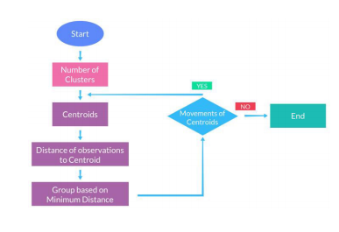

The generic algorithm is very simple as presented in fig.1.

* Select K points as initial centroids.
* Repeat
* Form K cluster by assigning each point to its closest centroid.
* Recomputed the centroid of each cluster until centroid does not change